**CHATBOT DEPLOYMENT WITH IBM CLOUD WATSON ASSISTANT-BUILD A PROJECT**

|  |  |
| --- | --- |
| **Date** | **04-10-2023** |
| **Team ID** | **676** |
| **Project Name** | **Chatbot Deployment with IBM Watson Assistant** |

**Table of Contents**

|  |  |
| --- | --- |
| 1 | Introduction |
| 2 | Problem Statement |
| 3 | Creation of Intent |
| 3.1 | Greetings |
| 3.2 | Ending Greetings 1 |
| 3.3 | Ending Greetings 2 |
| 4 | Error Handling |
| 5 | Creation of Entities |
| 5.1 | Starting Greetings 1 |
| 5.2 | Ending Greetings 2 |
| 6 | Creating Dialog Flow |
| 7 | Train the Bot |
| 8 | Conclusion |

**1. Introduction**

In today's fast-faced digital world, businesses and organizations are constantly seeking innovative ways to engage with their audience, provide quick access to information, and enhance customer experiences. One such solution is the creation of a helpful virtual guide using IBM Cloud Watson Assistant. This virtual guide can be customized to assist users on popular messaging platforms like Facebook Messenger and Slack, offering a friendly and informative conversational experience.

**2. Problem Statement**

Create a helpful virtual guide using IBM Cloud Watson Assistant. Customize the chatbot to assist users on popular messaging platforms like Facebook Messenger and Slack. Provide useful information, answer FAQs, and offer a friendly conversational experience. Empower users with quick access to information and create meaningful connections through your virtual guide.

**3. Creation of INTENTS**

Creating intents in IBM Watson Assistant is a foundational step in building a chatbot. It involves defining the purposes or goals of user interactions within a designated workspace. In this process, you name each intent, like "How can I help you? and provide sample user phrases that relate to that intent. Training your chatbot helps it recognize these intents and understand user messages. You can also use entities to extract specific information from user inputs. Moreover, you define how the chatbot should respond to each intent by creating dialog nodes. Testing is crucial to ensure that the chatbot correctly understands and interacts with users. It's a dynamic process, and feedback from real users guides ongoing improvements. Additionally, it's important to handle messages that fall outside of recognized intents by creating a "fallback" intent. Continuously monitoring and refining your chatbot's intents ensures that it becomes more adept at understanding and assisting users, providing a better conversational experience.

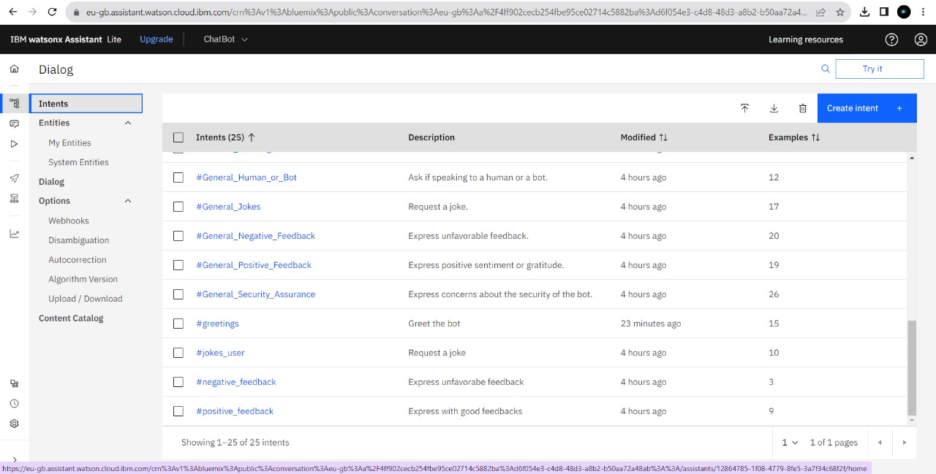

**EXAMPLE**

**3.1. Greetings**

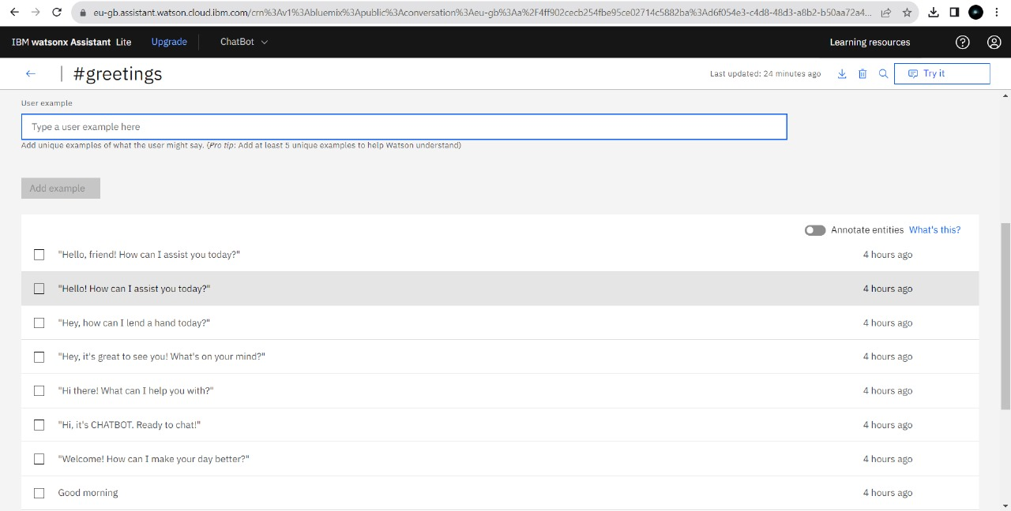

**3.2. Ending Greetings 1**

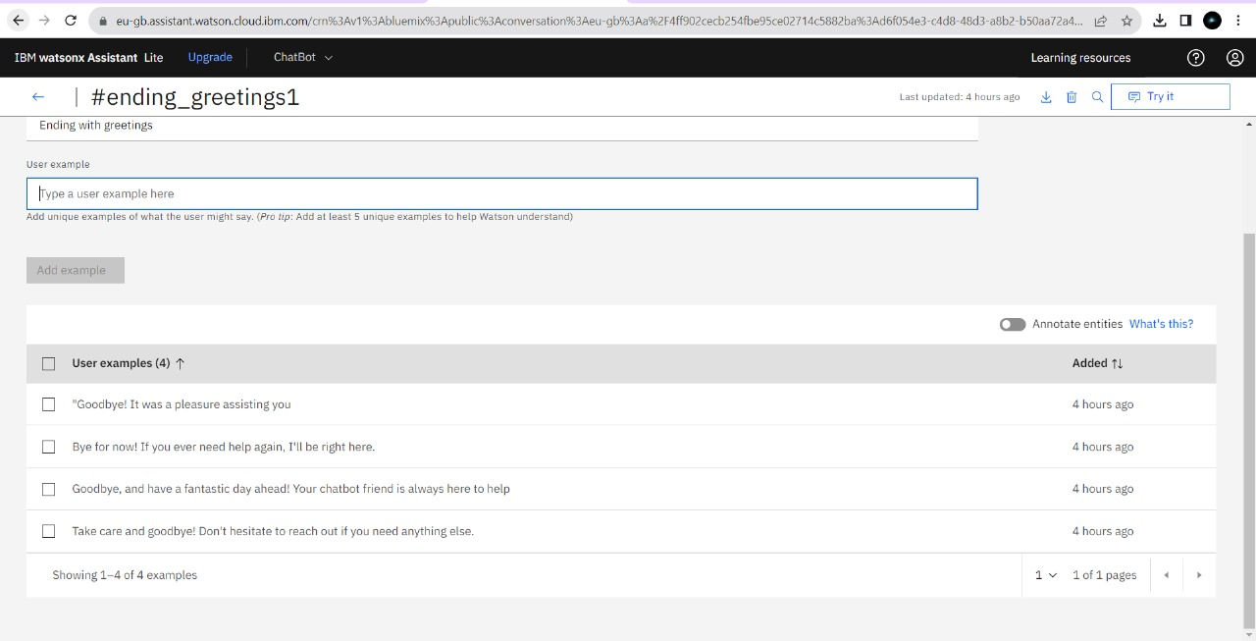

**3.3. Ending Greetings 2**

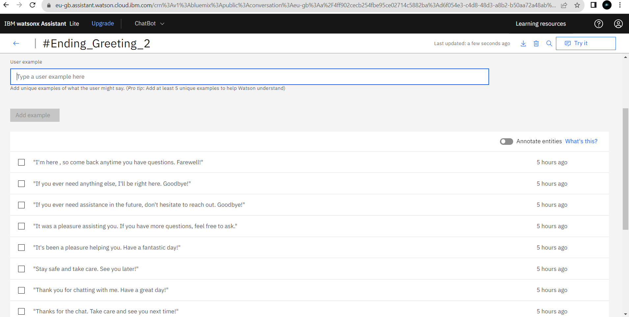

**4. Error Handling**

Error handling in chatbot deployment with IBM Cloud Watson Assistant is all about addressing user confusion or unsupported requests. Start by defining a "fallback" intent to capture messages the chatbot can't grasp. Fill it with various training examples to cover a wide range of potential user errors. You can also set up contextual actions, like asking for clarification or offering help resources. Test and fine-tune this error handling to ensure it works smoothly. Continuously watch user interactions and refine the system. IBM Watson Assistant provides system entities for extracting specific information. In more complex or sensitive cases, consider integrating with live agents for human assistance.

**5. Creation of Entities**

Creating an entity in IBM Cloud Watson Assistant is a way to teach your chatbot to recognize and extract specific pieces of information from user messages.The chatbot uses these examples to understand and extract relevant information from user inputs, making it more effective at responding to queries that involve that entity. It's a way to add structure to conversations and ensure that the chatbot can process and act upon important details provided by users. Once you create the entity and define its values, you can use it to enhance your chatbot's ability to address user requests accurately

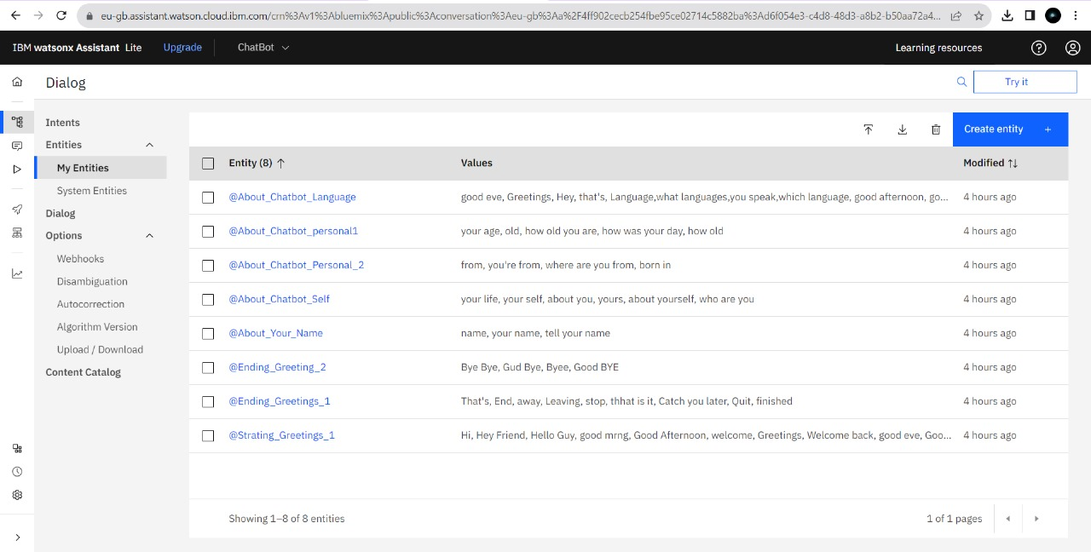

**Example**

**5.1.Starting Greeting 1**

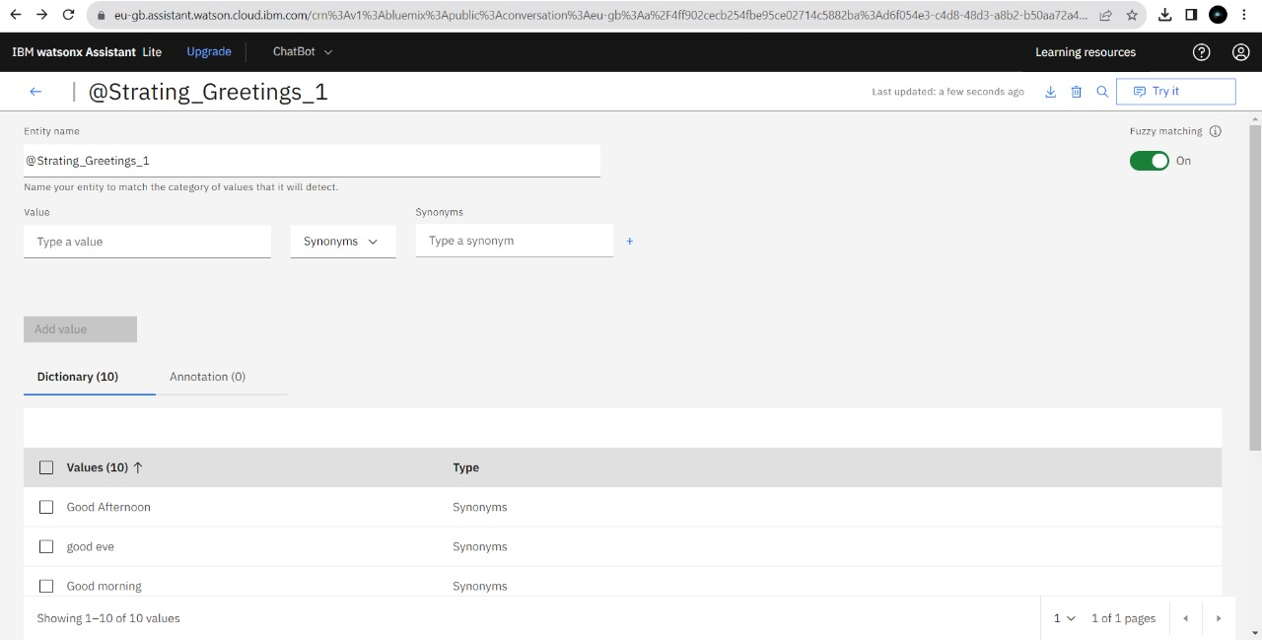

**5.2.Ending Greeting 1**

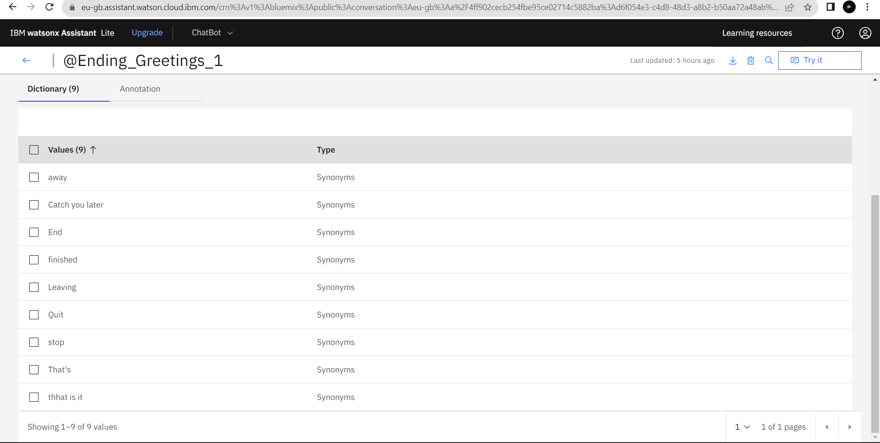

**6.Creating Dialog Flow**

Creating a dialog flow means designing the structure and sequence of interactions between the chatbot and the user to provide a smooth and effective conversational experience.

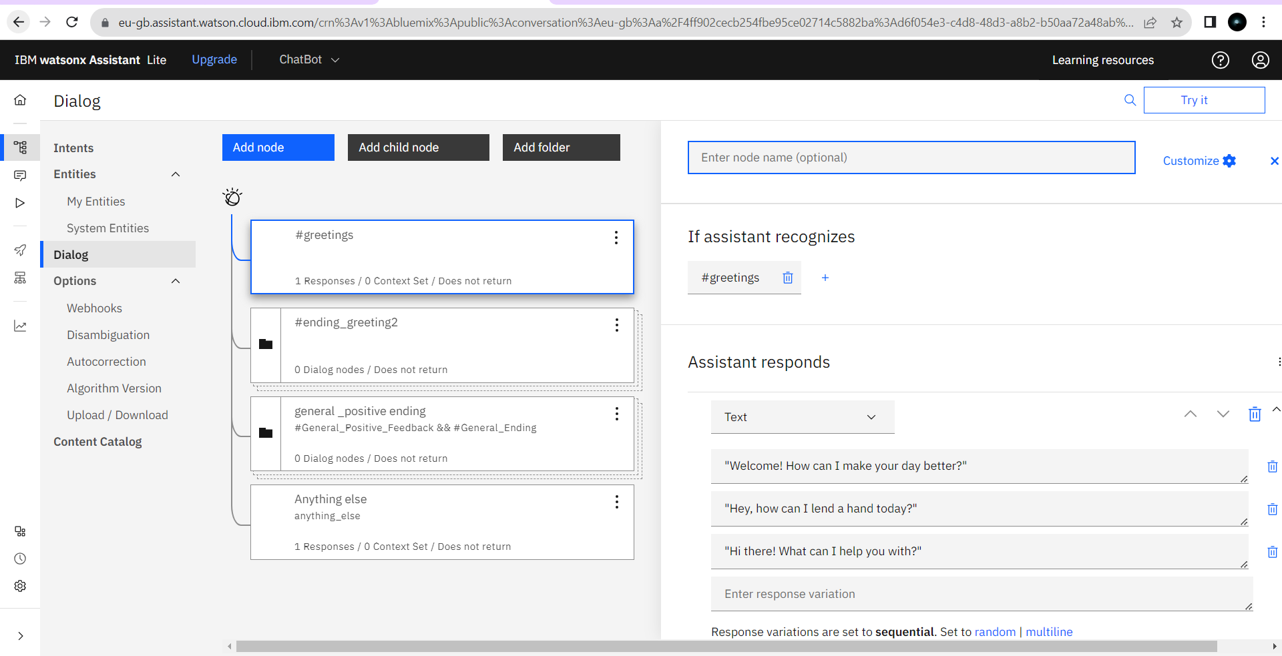

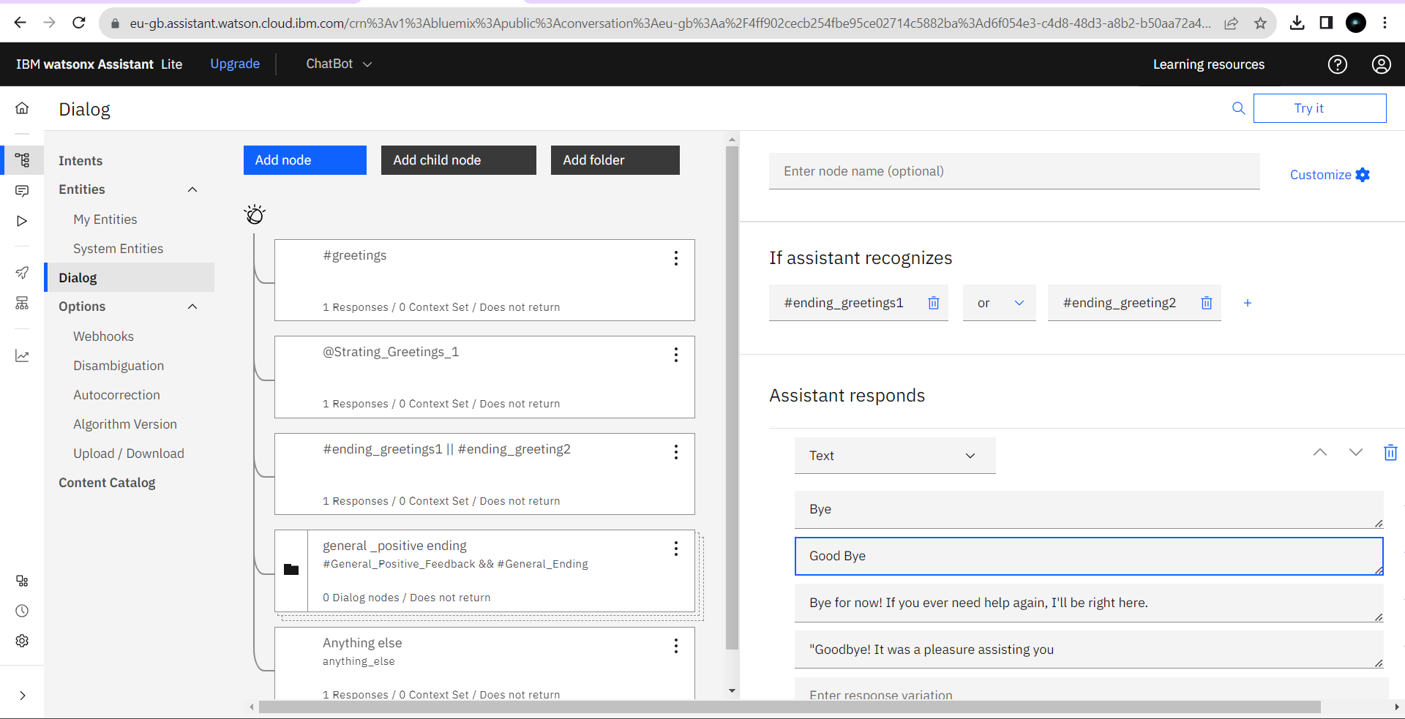

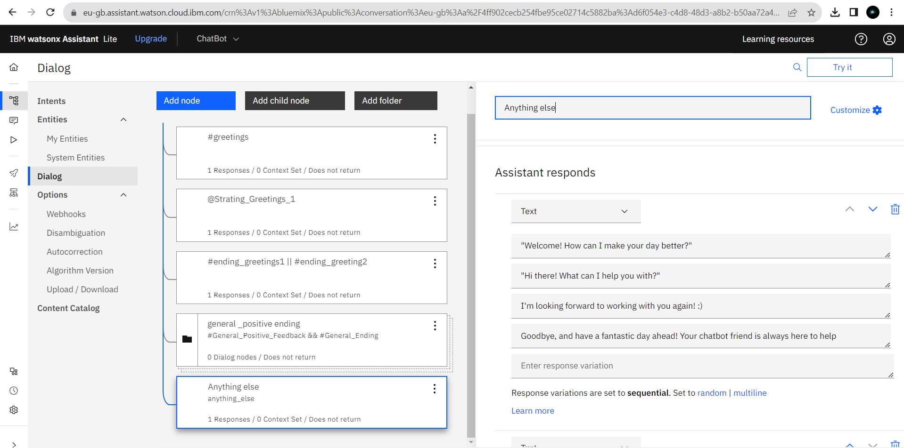

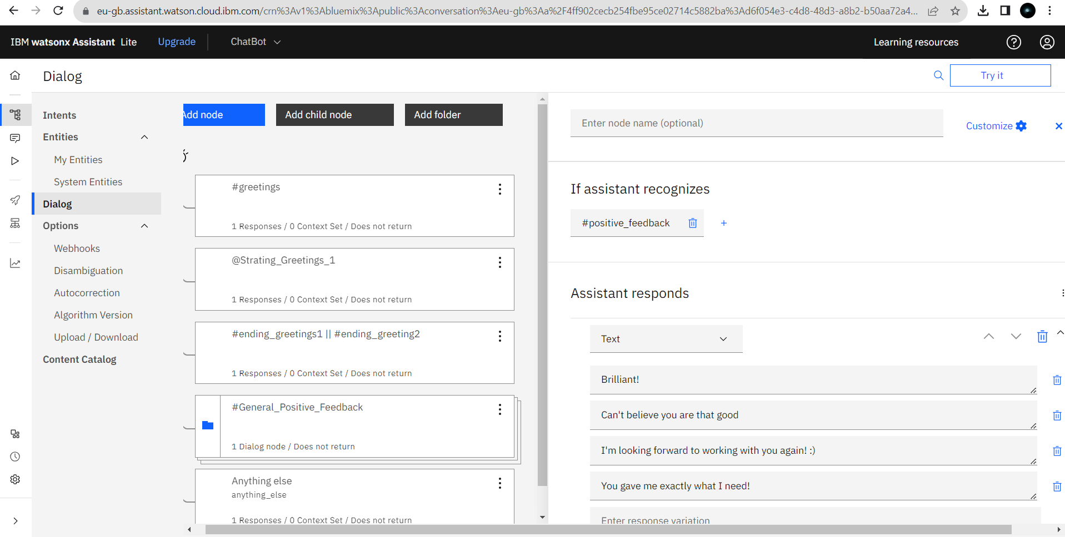

**7.Train the Bot**

Continuous user testing and feedback loops are essential for refining the chatbot's design and functionality, ensuring it evolves to meet changing user needs. Ultimately, a user-centric approach leads to a chatbot that provides a positive and satisfying user experience.

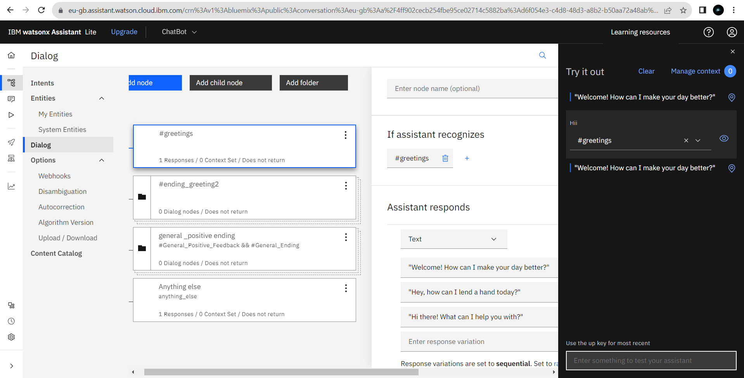

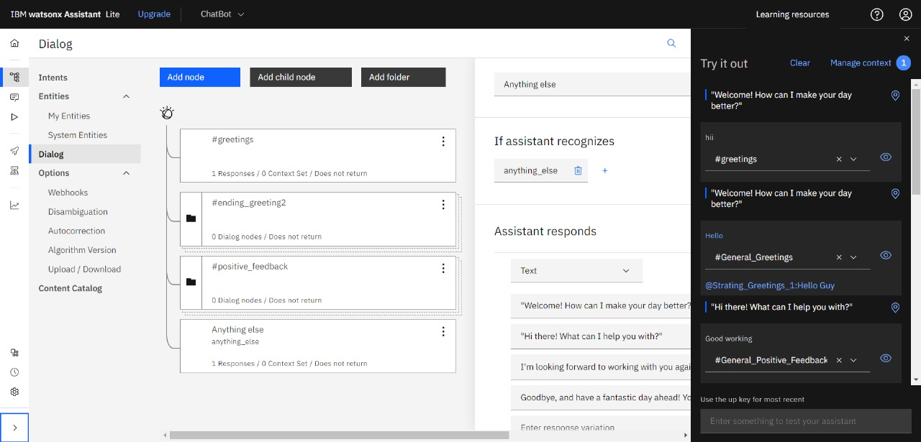

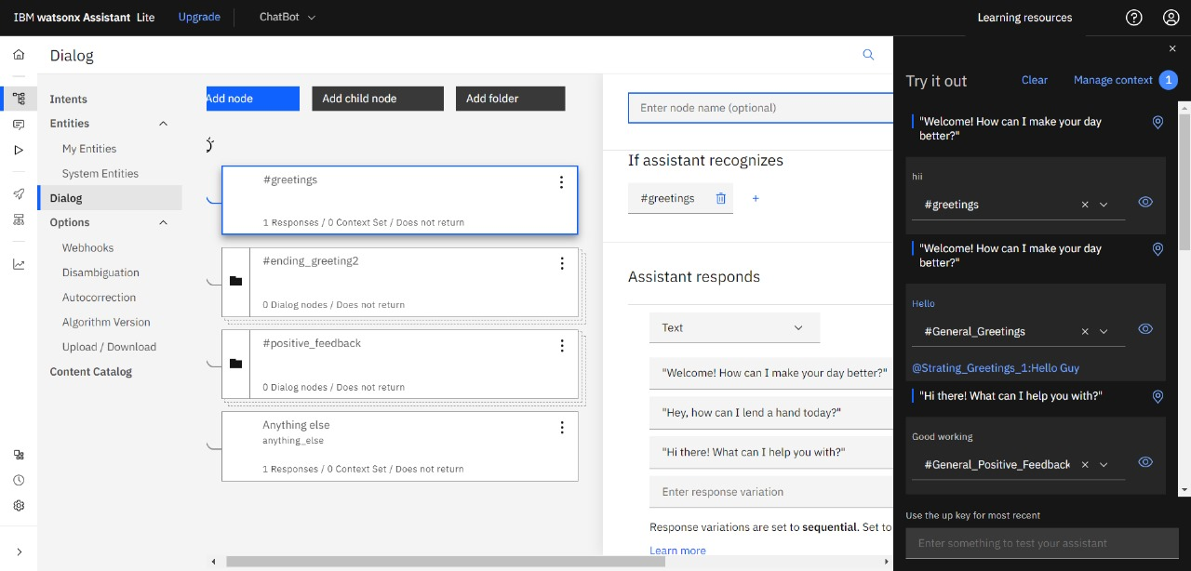

**8. Conclusion**

In conclusion, deploying a chatbot using IBM Cloud and integrating it with Watson Assistant offers a powerful and flexible solution for a wide range of project requirements. IBM Cloud Foundry provides a robust platform for hosting applications, ensuring scalability, security, and reliability. Watson Assistant, on the other hand, empowers the chatbot with natural language understanding capabilities, allowing it to interact with users effectively .This combination allows you to create a chatbot that can serve various functions, whether it's customer support, information retrieval, or process automation. Once you have performed the relevant activities and configured the chatbot, you can create a comprehensive document summarizing the project's architecture, deployment, and capabilities. This document will be invaluable for assessment, showcasing how IBM Cloud and Watson Assistant were leveraged to build a chatbot that meets the project's specific requirements effectively.